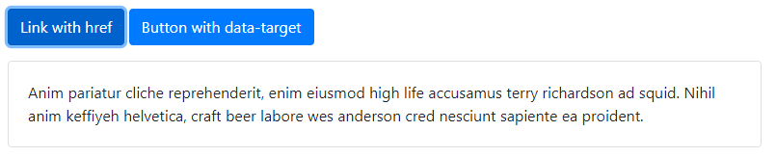

<p>

<a class="btn btn-primary" data-toggle="collapse" href="#collapseExample" role="button" aria-expanded="false" aria-controls="collapseExample">

Link with href

</a>

<button class="btn btn-primary" type="button" data-toggle="collapse" data-target="#collapseExample" aria-expanded="false" aria-controls="collapseExample">

Button with data-target

</button>

</p>

<div class="collapse" id="collapseExample">

<div class="card card-body">

Anim pariatur cliche reprehenderit, enim eiusmod high life accusamus terry richardson ad squid. Nihil anim keffiyeh helvetica, craft beer labore wes anderson cred nesciunt sapiente ea proident.

</div>

</div>